Kaya Vong
Coach
kvvball2@gmail.com

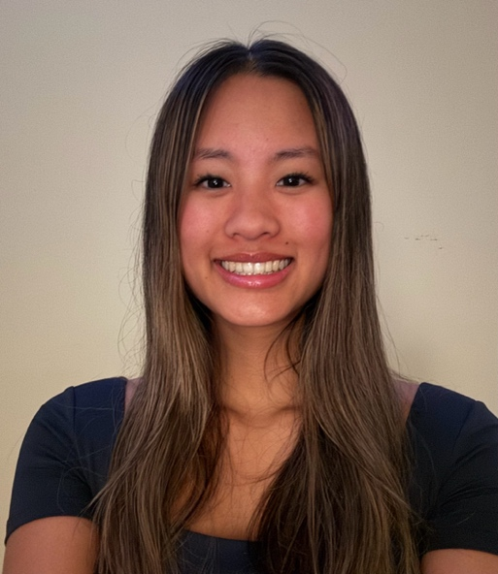
Bio: Hi! I’m Kaya. I started playing volleyball when I was in 4th grade at the Boys and Girls Club of Bellevue. My love for the sport started there and continued to grow over the years. It has been so fulfilling to coach at the same location I used to play at when I first started volleyball, and my only hope is to help foster growth and love for the sport, as the club did for me.

Playing experience
- 7 years of club volleyball
- Played 6 years of club at Sudden Impact Volleyball Club
- 4 years on the High School Varsity team at Liberty High School, 2-time team captain, 2-time All-league KingCo First team

Coaching experience:
- 3 years of coaching at the Boys and Girls Club of Bellevue
- Coached Boys and Girls Club teams ages 4th grade- 9th grade
- Volleyball summer camp coach at Sudden Impact Volleyball Club
- Assistant coach at Sudden Impact Volleyball Club for the 2022 U11 team
- 4 years total coaching experience

